Physics 30 1990 January

- Monochromatic light passes through a double slit of separation 1.5 x 10⁻⁴ m. If bright interference bands are 1.4 x 10⁻² m apart on a screen that is 3.7 m from the double slit, the calculated wavelength of the light would be
A. 4.2 x 10⁻⁷ m
B. 5.4 x 10⁻⁷ m
C. 5.7 x 10⁻⁷ m
D. 6.2 x 10⁻⁷ m

Use the following information to answer the next question.

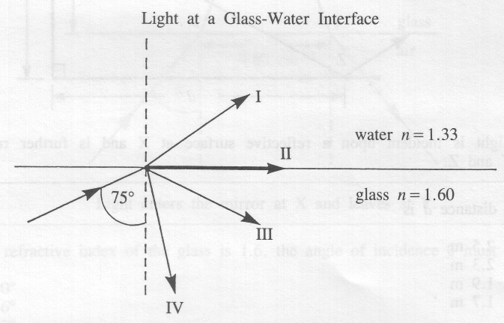

- The correct path of the ray is shown by
A. I
B. II
C. III
D. IV

- To determine the speed of light, Huygens used
A. toothed wheels
B. flashing lanterns
C. astronomical data
D. octagonal mirrors

Use the following information to answer the next question.

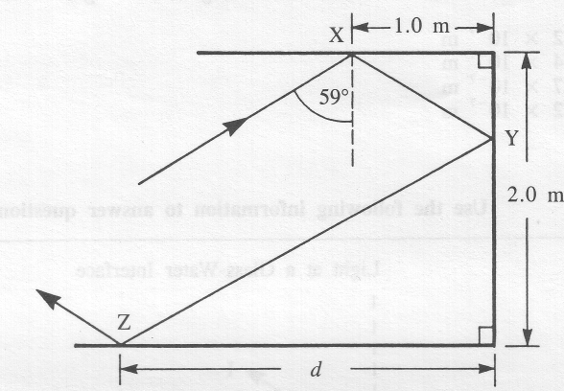

Light is incident upon a reflective surface at X and is further reflected at Y and Z.

- The distance d is
A. 2.5 m
B. 2.3 m
C. 1.9 m
D. 1.7 m

- If a spaceship could move at 1/1500th the speed of light, how long would it take to travel 2.50 light-years? (A light-year is the distance travelled by light in one year.)
A. 3.75 x 10³ s
B. 1.18 x 10¹¹ s
C. 8.46 x 10¹² s
D. 3.56 x 10¹⁹ s

- Wavelength is not a good criterion for categorizing light because wavelength
A. is inversely proportional to frequency
B. is directly proportional to speed
C. changes during diffraction
D. changes during refraction

Use the following information to answer the next question.

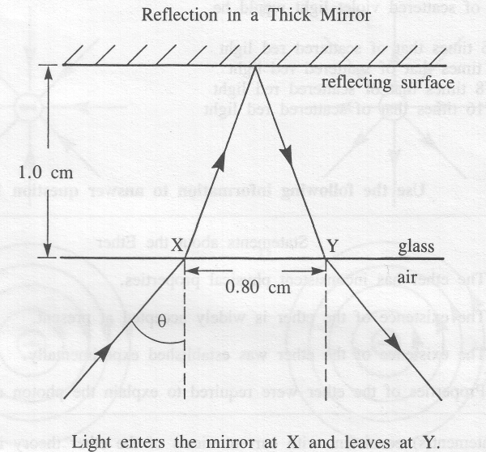

- If the refractive index of the glass is 1.6, the angle of incidence 0 must be
A. 40º
B. 36°
C. 22°
D. 13°

- Light passing from glass (n = 1.5) into water (n = 1.3) will
A. increase in both speed and wavelength
B. decrease in both speed and wavelength
C. increase in speed but decrease in wavelength
D. decrease in speed but increase in wavelength

- The formation of the Poisson spot is a result of
A. refraction and destructive interference
B. diffraction and destructive interference
C. refraction and constructive interference
D. diffraction and constructive interference

- The energy of scattered light is directly proportional to the fourth power of the frequency. If the frequency of violet light is twice that of red light, then the energy of scattered violet light would be
A. 16 times that of scattered red light
B. 8 times that of scattered red light
C. 1/8 times that of scattered red light
D. 1/16 times that of scattered red light

Use the following information to answer the next question.

Statements about the Ether
I. The ether has inconsistent physical properties.
II. The existence of the ether is widely accepted at present.
III. The existence of the ether was established experimentally.
IV. Properties of the ether were required to explain the photon model of light.

- The statement(s) consistent with current views of the ether theory is(are)
A. I only
B. III only
C. I and II
D. II and IV

Use the following information to answer the next question.

Energy Beams
I. X-rays
II. Cathode rays
III. Red laser light
IV. Stream of alpha particles

- Which energy beams can be deflected by an electric field?
A. I and II
B. I and III
C. II and IV only
D. II, III, and IV

- The electric field of an electron at rest may be best represented by

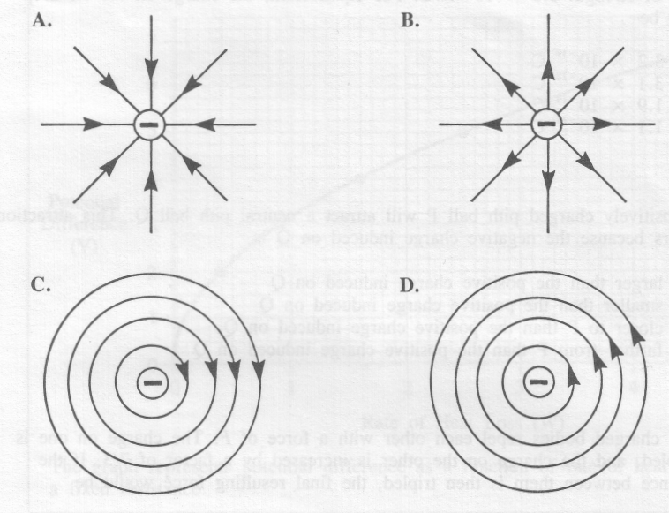

Use the following information to answer the next question.

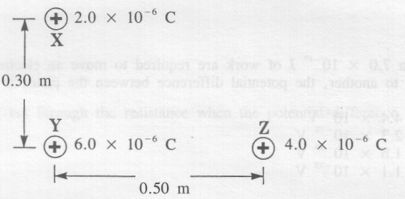
Charges X, Y and Z, with magnitudes as shown in the diagram, are placed at the vertices of a right-angled triangle.

- The force on charge Y has a magnitude of
A. 2.1 N
B. 1.5 N
C. 1.0 N
D. 0.34 N

- A charged oil drop of mass 1.9 x 10⁻¹⁵ kg is suspended in a vertical electric field of strength 6.0 x 10³ N/C. For equilibrium, the charge on the oil drop must be
A. 3.2 x 10⁻¹⁹ C
B. 3.1 x 10⁻¹⁸ C
C. 1.9 x 10⁻¹⁴ C
D. 1.1 x 10⁻¹¹ C

- A positively charged pith ball P will attract a neutral pith ball Q. This attraction occurs because the negative charge induced on Q is
A. larger than the positive charge induced on Q
B. smaller than the positive charge induced on Q
C. closer to P than the positive charge induced on Q
D. farther from P than the positive charge induced on Q

- Two charged bodies repel each other with a force of F. The charge on one is doubled, and the charge on the other is increased by a factor of 7/3. If the distance between them is then tripled, the final resulting force would be
A. 42F
B. 14F/3
C. 14F/27
D. F/9

- When 7.0 x 10⁻¹⁵ J of work are required to move an electron from one charged plate to another, the potential difference between the plates is
A. 4.4 x 10⁴ V
B. 2.3 x 10⁻¹⁹ V
C. 1.6 x 10⁻¹⁹ V
D. 1.1 x 10⁻³³ V

- When Ohm's Law applies, the current varies
A. directly as the voltage and directly as the resistance
B. directly as the voltage and inversely as the resistance
C. inversely as the voltage and directly as the resistance
D. inversely as the voltage and inversely as the resistance

Use the following information to answer the next two questions.

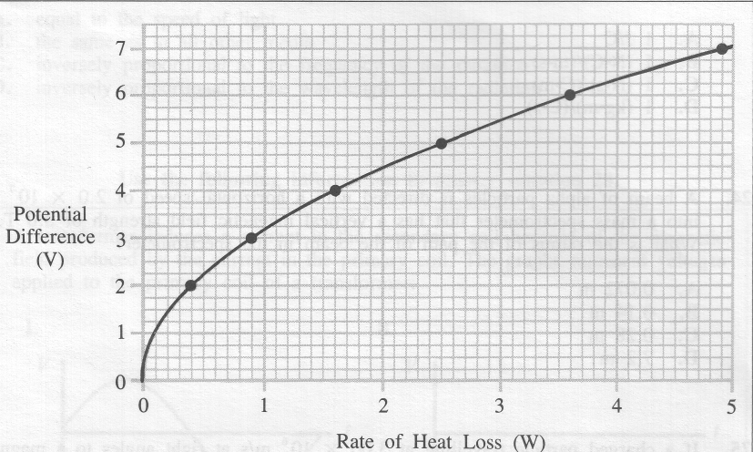

The graph represents potential difference as a function of rate of heat loss for a fixed resistance.

- The magnitude of the resistance is
A. 1.6 Ω
B. 2.5 Ω
C. 6.4 Ω
D. 10 Ω

- What is the current through the resistance when the potential difference is 6.0 V?
A. 0.60 A
B. 1.7 A
C. 3.6 A
D. 22 A

- The magnetic force experienced by a charged particle moving through any magnetic field is
A. always greater than zero
B. constant regardless of the direction of the field
C. maximum when the velocity is parallel to the field
D. maximum when the velocity is perpendicular to the field

- Magnetic field strength is measured in tesla (T). One set of units equivalent to 1 T is 1 N/(A•m). Another set of units equivalent to 1 T is
A. 1 J/C
B. 1 (N•C)/(m•s)
C. 1 (N•s)/(C•m)
D. 1 (kg•m)/(C•s)

- A beam of alpha particles is directed with a horizontal speed of 2.0 x 10⁷ m/s into a mass spectrometer that has a vertical magnetic field strength of 3.0 T. What is the radius of the path of the beam in the spectrometer?
A. 0.072 m
B. 0.14 m
C. 0.28 m
D. 7.2 m

- If a charged particle travelling at 3.00 x 10⁶ m/s at right angles to a magnetic field of 0.125 T experiences a deflecting force of 1.20 x 10⁻¹³ N, the particle could be
A. a proton
B. a neutron
C. an electron
D. an alpha particle

Use the following information to answer the next question.

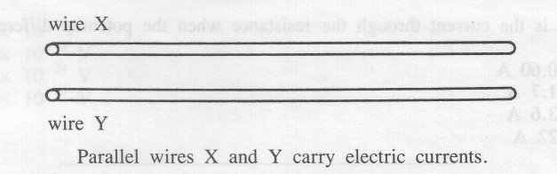

- If the direction of the current in wire X is reversed, then
A. the current in wire Y would be reversed
B. only the magnetic force on wire X would be reversed
C. only the magnetic force on wire Y would be reversed
D. the magnetic forces on both wires X and Y would be reversed

- In a vacuum, the speed of all forms of electromagnetic radiation is
A. equal to the speed of light
B. the same as in all other media
C. inversely proportional to the frequency of the radiation
D. inversely proportional to the wavelength of the radiation

Use the following information to answer the next question.

A transformer induces a current in the secondary coil because of the magnetic field produced by the current in the primary coil. The graphs represent voltages applied to the primary coil of a transformer:

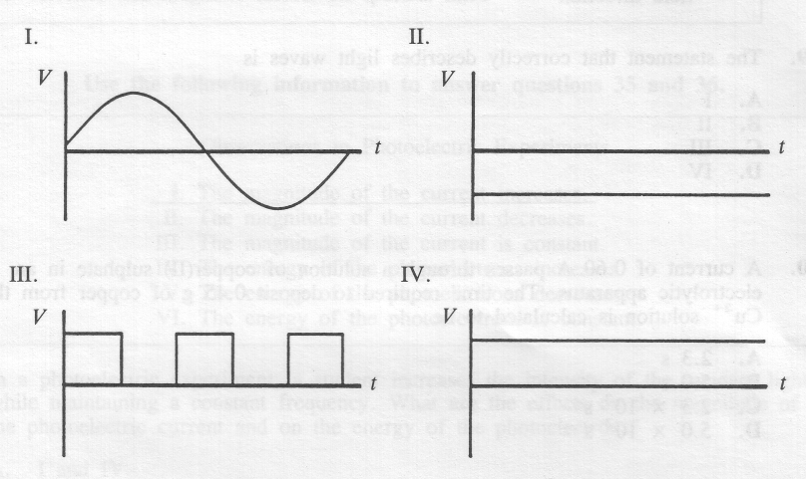

- Which signals would cause the induction of a current in the secondary coil?
A. I and III
B. I and IV
C. II and III
D. III and IV

Use the following information to answer the next question.

Possible Descriptions of Light Waves

I. Transverse waves with the magnetic field direction at 180° to the electric field direction

II. Transverse waves with the magnetic field direction at 90° to the electric field direction

III. Longitudinal waves with the magnetic field direction at 180° to the electric field direction

IV. Longitudinal waves with the magnetic field direction at 90° to the electric field direction

- The statement that correctly describes light waves is
A. I
B. II
C. III
D. IV

- The experimental value of q/m for a proton is 9.6 x 10⁷ C/kg. The value of q/m for an alpha particle is
A. 1.9 x 10⁸ C/kg
B. 9.6 x 10⁷ C/kg
C. 4.8 x 10⁷ C/kg
D. 2.4 x 10⁷ C/kg

- An electric field of 4.3 x 10⁴ N/C and a perpendicular magnetic field of 1.3 x 10⁻³ T are applied simultaneously to a beam of electrons. If the beam remains undeflected, the speed of the electrons must be
A. 5.6 x 10⁻¹¹ m/s
B. 3.0 x 10⁻⁸ m/s
C. 1.6 x 10⁴ m/s
D. 3.3 x 10⁷ m/s

- To demonstrate that electric charges in nature are made up of whole-number multiples of the smallest charge, Millikan used
A. three forces: gravitational, magnetic, and electric
B. two forces: gravitational and electric
C. two forces: magnetic and electric
D. only the electric force

- The Bohr theory best explains
A. the photoelectric effect
B. intensities of spectral lines
C. emission and absorption spectra of hydrogen
D. electric and magnetic effects on spectral lines

Use the following information to answer the next two questions.

Observations in Photoelectric Experiments

I. The magnitude of the current increases.
II. The magnitude of the current decreases.
III. The magnitude of the current is constant.
IV. The energy of the photoelectrons increases.
V. The energy of the photoelectrons decreases.
VI. The energy of the photoelectrons is constant.

- In a photoelectric experiment, a student increases the intensity of the incident light while maintaining a constant frequency. What are the effects on the magnitude of the photoelectric current and on the energy of the photoelectrons?
A. I and IV
B. I and VI
C. III and IV
D. III and VI

- In a photoelectric experiment, a student decreases the intensity of the incident light while increasing its frequency. What are the effects on the magnitude of the photoelectric current and on the energy of the photoelectrons?
A. II and IV
B. II and V
C. III and IV
D. III and VI
________________________________

- Light with a frequency of 8.50 x 10¹⁴ Hz strikes a surface that has a work function of 3.00 eV. The maximum kinetic energy of an emitted photoelectron is
A. 5.6 x 10⁻¹⁹ J
B. 4.5 x 10⁻¹⁹ J
C. 4.0 x 10⁻¹⁹ J
D. 8.4 x 10⁻²⁰ J

- The stopping voltage for photoelectrons in a photoelectric cell is used to determine their
A. mass
B. energy
C. momentum
D. charge-to-mass ratio

- An electron makes a transition from the fourth energy level of a hydrogen atom to the ground state. The wavelength of the radiation emitted is
A. 9.7 x 10⁻⁸ m
B. 1.2 x 10⁻⁷ m
C. 3.6 x 10⁻⁷ m
D. 4.9 x 10⁻⁷ m

- The radius of the fourth Bohr orbit of the hydrogen atom is
A. 3.31 x 10⁻¹² m
B. 1.32 x 10⁻¹¹ m
C. 2.12 x 10⁻¹⁰ m
D. 8.46 x 10⁻¹⁰ m

- The energy required to remove the outermost electron of a sodium atom is 5.1 eV. If an electron with a speed of 1.5 x 10⁶ m/s strikes and ionizes a sodium atom, the maximum possible kinetic energy of the incident electron after the collision would be
A. 1.3 eV
B. 5.1 eV
C. 6.4 eV
D. 11.5 eV

- An inadequacy of the Bohr atomic model is that
A. a radius cannot be calculated for hydrogen
B. an electron energy cannot be calculated for hydrogen
C. the spectrum of hydrogen cannot be predicted accurately
D. the relative brightness of the spectral lines of hydrogen cannot be predicted accurately

Use the following information to answer the next question.
Statements from Various Models of the Atom

I. The atom is neutral.
II. The bulk of the volume is empty space.
III. A negative fluid creates the bulk of the volume.
IV. The positive charges have a much greater mass than the negative charges.

- Which statements are consistent with current understanding of the atom?
A. I and IV only
B. III and IV only
C. I, II, and IV
D. II, III, and IV

- When will the rest mass of an object be greater than its relativistic mass?
A. Never
B. Only at low speeds
C. Only at high speeds
D. Only at the speed of light

- The total potential difference through which a proton must be accelerated from rest to acquire a relativistic mass of 1.72 x 10⁻²⁷ kg is
A. 9.7 x 10⁸ V
B. 9.4 x 10⁸ V
C. 1.4 x 10⁸ V
D. 2.8 x 10⁷ V

- The momentum of an X-ray photon is directly proportional to its
A. mass
B. velocity
C. frequency
D. wavelength

- An alpha particle and an electron are travelling at the same speed. The de Broglie wavelength for the alpha particle is
A. longer because of the greater mass of the alpha particle
B. shorter because of the greater mass of the alpha particle
C. longer because of the greater charge of the alpha particle
D. shorter because of the greater charge of the alpha particle

Use the following information to answer the next question.

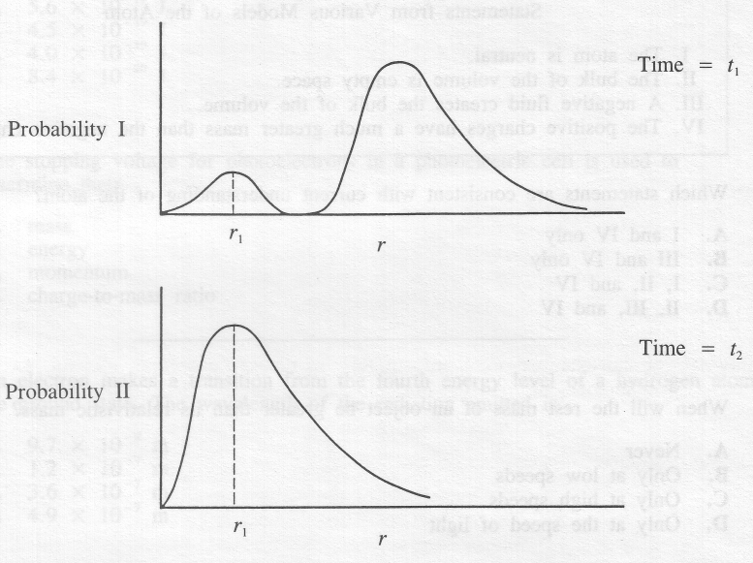
The two diagrams represent the electron probability distribution for a hydrogen atom at different times. Probability II occurs some time later than Probability I.

Comparing the states of the hydrogen atom at the times t₁ and t₂, the change that has occurred in the atom is that

A. the average value of r has increased
B. the probability of finding the electron at r = 0 has increased
C. an electron has moved from the ground state to an excited state
D. an electron has moved from an excited state to the ground state

- Heisenberg's Uncertainty Principle states that the more accurately we know the position of a particle, the less accurately we know its
A. size
B. charge
C. amplitude
D. momentum

